Gena Mangano

Mktg 311

Marketing Communications Audit

December 4, 2013

Dr Pepper Ten

**Section 1: Advertising**

The 10-calorie but flavorful soft drink, Dr Pepper Ten is targeted towards younger men. The ad campaign, called “It’s not for women”, is designed to appeal to men as being manly enough. According to the article “Dr Pepper's risky strategy — niche marketing or alienating?” studies show that men purchase 44.3 percent of diet soda. Men ages 18-24 purchase only 9.7 percent and men ages 24-34 purchase 15.8 percent (Harrison). *The demographic segmentation for Dr Pepper Ten is men ages 24-35 that are not satisfied with the taste of diet sodas.* *The psychographic segmentation for Dr Pepper Ten would be action oriented- young, enthusiastic, and rebellious while also being skeptical of new ideas. Dr Pepper is targeting the younger men that usually avoid low calorie drinks, but still are concerned about caloric content. Men this age are often more self conscious, and are also more concerned with their appearance of drinking a diet drink because it can be perceived as not being masculine. At a younger age men are also not as concerned about their health, and enjoy purchasing whatever they please when living outside their parent’s home.*

*Dr Pepper is creating a special niche, and separating the 10-calorie drink from their 0-calorie drink. A niche is also created when saying the product is only for men.* Dr Pepper even has a special section on their Facebook page that women can’t access. Jim Trebilock, the Executive Vice-president of Dr Pepper says, “it’s a way to start the conversation that can spread and get people engaged in the product” (Harrison). The Facebook page contains games and videos, poking fun at women while shooting high heels and lipstick. It also has a “man quiz” with questions on fishing and hunting. *Creating an exclusive Facebook page gives men a fun place to come online, and belong to.* Dr Pepper also created a mobile app, which has “man’ments” such as “Thou Shalt Not Pucker Up. Kissy faces are never manly” and “Thou Shalt Not Make a ‘Man-Gagement’ Album. That is all”. *It is meant to be comical, but still appeals to men and creates a light humor that is associated with the new product.*

*The behavioral segmentation for Dr Pepper Ten is frequent buyers. Consumers of Dr Pepper are also most likely loyal customers, since people are usually set on always drinking one brand of soda. Those who are concerned about their health would switch to the Dr Pepper Ten. Benefits sought would be a soda with fewer calories and less sugar, but still a bold flavor.*

*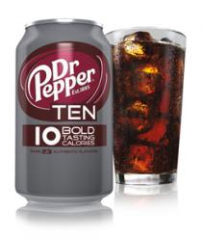The packaging of the soda can and the box is also appealing to men*.

*The can is a gunmetal gray color that contrast well with the maroon logo. It also says “10 bold tasting calories” that tells the consumers that it is low in calories but still has the strong Dr Pepper taste. The box the cans come in also has a very eye-catching masculine design with industrial rivets and the same gunmetal gray color.*

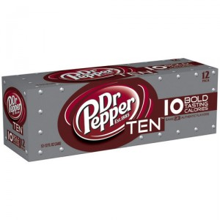

Print Ad #1:

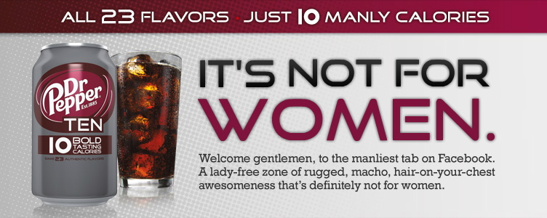

The first print ads features colors that would appeal more to men by offsetting the classic maroon Dr Pepper color with a slate gray background. The “It’s Not For Women” is written in all caps, and with a bold more industrial style font. *This is the first thing that is read on the ad since it stands out. It catches the reader’s attention by being humorous and targets men directly by telling who the product is designed for.* “Women” being the only text that is maroon *also makes it stand out. The slogan is also very short and abrupt with the period and to the point, and will stick in head’s of consumers.*

The top reads “All 23 Flavors – Just 10 Manly Calories” *which lets the consumer know that the drink still has all 23 of the classic Dr Pepper flavors that the brand is known for, but still being only 10 calories. They also made sure to include the word “manly” to remind readers that it is still masculine to be calorie conscious.*

*After reading the main headlines, if the reader is still viewing the ad their eyes will continue to the bottom where they go into more detail. They appeal to men by “welcoming” consumers to their Facebook page.* They include descriptive words like “…rugged, macho, hair-on-your-chest awesomeness” *that are comical while still depicting a masculine vibe. The not-too-technical wording keeps it friendly and inviting, while still encouraging Facebook likes.*

*The primary message being communicated in this ad is that Dr Pepper Ten is a 10 calorie drink for men, and the a secondary message is that it still has the 23 bold flavors of Dr Pepper.*

*I would rate the effectiveness of the ad as a 4. I believe that it is effective at catching the attention of men since it is visually appealing, slightly humorous, and gives the sense of exclusiveness. However I would not rate it a perfect 6. I think if they changed their wording to “It’s not JUST for Women”, that would also appeal to women. That would let the consumer know that men can drink the soda as well as men, thus reaching a broader audience. I believe they could have also done more to draw they eye in with less wording since the majority of people do not hold their eyes on an ad that long.*

Print Ad #2:  
  
 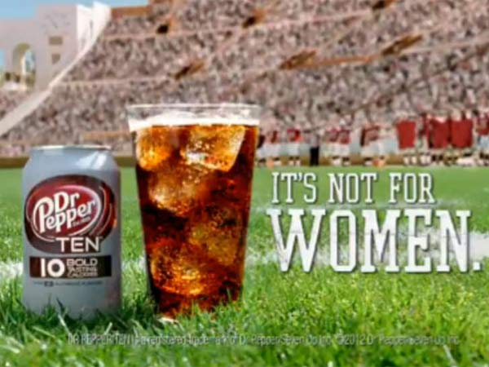

The second print ad shows a can and a glass of Dr Pepper Ten sitting on a football field. The text has the slogan “It’s Not For Women” written in a bold, all caps, and rugged looking font. The font also appears to be one that is similar to a sports team name or university. *The slogan again appeals to men only, with short direct wording that is catchy. This being the only wording leaves the reader thinking.*

*The background being a football (or any field sport) stadium appeals to men especially during football season. Soda is typically consumed during sporting events, tailgating, barbeques, and other outdoor settings. This reminds the consumer that they should purchase the soda when shopping for these events. Having the masculine can in front focus also grabs the attention. The large glass filled with ice makes the soda look bubbly and appealing. This would make readers crave a thirst-quenching soda, also with the sunny lighting of the photo.*

*The primary message of this ad is the product is a low calorie, but still flavorful drink. The secondary message is that the soda is perfect for men during outdoor events.*

*Overall I would give this ad a 5 rating. I like the simplicity of it and the message with the sporting event. Having only a few words catches the attention and gets the point across. No further explanation of the product was needed with more wording since the wording “10 bold tasting calories” is still visible on the can. The wording on the can perfectly explains the product in the shortest way possible.*

TV Commercial #1:

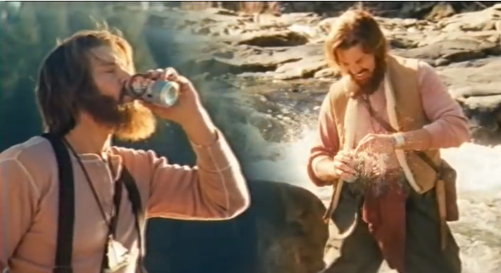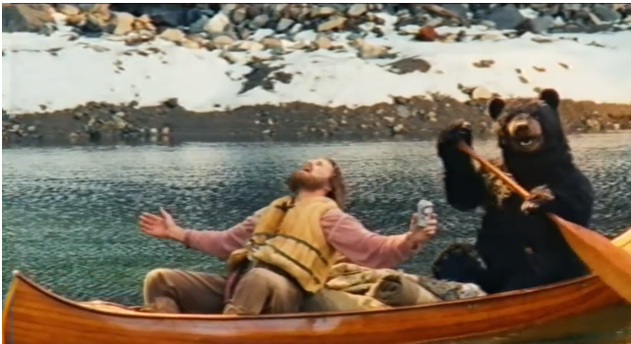 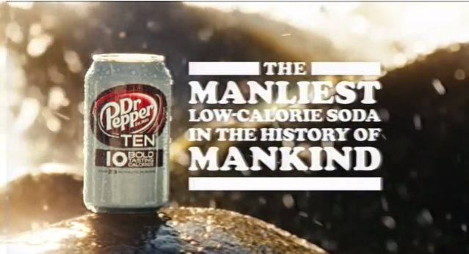

The Dr Pepper Ten Mountain Man commercial features a man outdoors trying to survive on his own. The jingle says, “a man just needs a place where he can be wild and free” followed by “10 calories” and the man yelling right after. *This is sending the message of victory, and joy of the soda only being 10 calories.* The product appears in the commercial several times when the man breaks the can out of the ice in the river, the bird brings it to him, and it shows him drinking it in the canoe with his bear friend. The commercial ends with a deep masculine voice saying “The Manliest Low Calorie Soda in the History of Mankind”. *This tagline references to the mountain man theme of the commercial from back in time when men had to survive in nature.* The commercial ends with the actor saying, “same bold flavor” *to ensure viewers that it does not taste like a diet drink.*

*The company’s primary message is that the soda is a low calorie but has the same bold flavor. However their secondary message would be* “Before we had tablet computers, computers, power steering, and vegans – men had non-ironic beards, hawk friends, and the ability to live off the land with nothing more than a Dr Pepper TEN” (“Dr Pepper TEN: Mountain Man Commercial”). *The ad shows the stereotypical gender role of men being active and adventurous, which also still being fit and strong by drinking a low calorie drink.*

*I would rate this commercial as a 5. The message portrayed is clear, and catches the viewers’ attention with the dramatic acting and animal friends. Men can relate to the man in the ad, as being independent and free to make his own choices of drink. They are depicting the drink as a “fuel” for manly activities. I would not give this ad a perfect score since not everyone finds the “dumb” humor funny. Maybe a simple ad showing guys at a tailgate party drinking the beverage would get the point across to everyone, and not turn people away who don’t find it funny.*

TV Commercial #2:

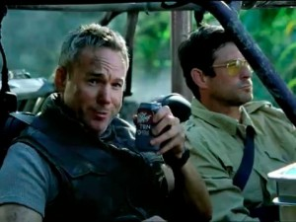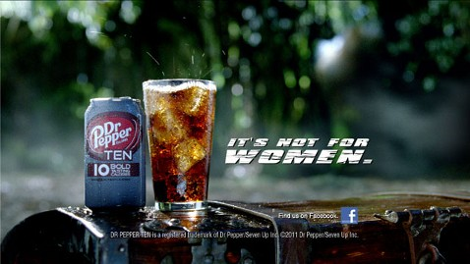

The second commercial features a mock action movie where men are battling snakes and shooting laser guns in the jungle. The actor opens with “Hey ladies, enjoying the film?” *which catches the attention of women and the action of the commercial catches the attention of men.* He then answers with “Of course not. Because this is our movie.” *This follows the rest of Dr Pepper’s campaign by targeting men specifically, and making the product seem exclusive to men.* He then calls it “our soda” and explains how the product is only ten “manly” calories but with all the flavors still. He also adds “it’s what guys want” *which reminds men that it is what they should want. Since women are also typically do the majority of grocery shopping, and make most of the purchasing decisions, this line reassures women that Dr Pepper Ten is the soda that they should purchase for the men in their home.* The actor then follows the stereotype of women by saying “so you can keep the romantic comedies and lady drinks” *to appeal to men’s humor. It also implies that women do not like action movies, and men want nothing to do with anything too feminine.*

*The primary message in this commercial is that men should choose Dr Pepper Ten since it has fewer calories, but with the same bold flavors. The secondary message is that men should not feel embarrassed to buy a “diet” drink because Dr Pepper Ten was created for them. Creating a soda with ten calories apposed to zero calories does not make it seem like a diet soda like what women drink, and it still has a bold flavor.*

*I would give this advertisement a 4 rating. I think it is effective at catching the attention of men because they want to continue watching to see what is going on. It also draws women in since the actor is speaking directly to women. I would not rate it a perfect score because women are still offended by the commercial saying that action movies are not for them, when there are women who like them.*

**Section 2: Public Relations**

Article #1:

<http://www.cnbc.com/id/100691083>

Author: Jane Wells

Publication: CNBC

Date: 30 April 2013

* The article “Dr Pepper Thinks 10 is the Magic Number” follows a reporter who gets to visit the Dr Pepper lab and see how Dr Pepper is engineering such a low calorie drink but still full of flavor.
* Dr Pepper has recently outperformed their competitors, Coke and Pepsi.
* All soda brands sales have continued to fall over the years with recent consumer awareness of the negative health effects of soda.
* Soda brands have been trying to market low calorie drinks instead of zero calorie “diet drinks”.
* Ten-calorie drinks make up more than 10% of total sales.
* The reporter samples different formulas of Stevia, a low calorie natural sweetener derived from an herb.
* The reporter did a blind taste test with Dr Pepper Ten and regular Dr Pepper and she said the two sodas were very similar and it was hard to tell the difference.
* Dr Pepper’s strategy has been to bring back customers who have switched away from sodas by giving them fewer calories and no diet taste.
* Since Dr Pepper Ten launched, they have come up with ten-calories versions of their other sodas- 7-Up, Sunkist, A&W and Canada Dry.
* Research from retailers showed that the people buying the new soda were people who had switched away from carbonated drinks entirely.
* The company has increased their marketing budget by $100 million and is taking more risks.

*In my opinion, this article is successful at promoting the new Dr Pepper Ten. After reading it myself, and watching the video, I wanted to try it out. I have been one of the consumers they are targeting that has quit drinking sodas entirely. After seeing how much sugar and calories are really in soda, it’s one thing I can cut out of my diet. However there is many times where I still crave a carbonated drink. I have always thought of Dr Pepper as the most flavorful soda brand, but always having too much sugar. The New Dr Pepper Ten is a great option to consider when purchasing a soda since it only has ten calories, and less sugar.*

*I would rate the article as a 6, since it was successful in convincing me tot try the product. The part that was most convincing was when the reporter said she had a hard time telling the difference between the two in a blind taste test. That tells me that they are very similar, and when not comparing the two side-by-side I might not even notice much difference.*

*It was also interesting that they showed inside the Dr Pepper lab. This gave viewers an inside look into what it takes to engineer a new soda. It was also helpful that they interviewed the CEO, and he gave insight to how the company is excelling during hard economic times. This would be useful for someone interested in investing in the brand. It was also interesting to know that they keep their 23 ingredients “top secret” and won’t reveal them to the public.*

Article #2:

<http://www.foxnews.com/health/2012/12/19/dr-pepper-to-debut-5-new-10-calorie-sodas/>

Author: none

Publicaiton: Fox News

Date: 19 December 2012

* The article “Dr Pepper to debut 5 new 10-calorie sodas describes the new low calorie drinks that Dr Pepper will release.
* The new drinks include 7-Up, Sunkist, Canada Dry, RC Cola and A&W Root Beer.
* The new 10-calories sodas are targeted towards men and women.
* The company says that most zero calorie sodas use artificial sweeteners.
* Dr Pepper Ten has just enough high-fructose corn syrup to maintain the soda taste.
* Coke and Pepsi are also trying to product better tasting low-calorie sodas.
* They believe that they can overcome the decline in soda sales.
* Flavored waters, sports drinks, and teas are becoming more popular with consumers being more health conscious.
* The ads for the new drinks will target both sexes with the theme of “Get Both”.
* A commercial for 7-Up with ten calories portrays a couple that can’t agree on anything but then find ways to compromise.
* The CEO of Dr Pepper predicts diet soda sales increasing from 20 percent to 40-50 in the next few years.
* Pepsi released Pepsi Next, which reduces the amount of high fructose corn syrup but by using artificial sweeteners.
* Coca-Cola did not see much potential in mid-calorie sodas.
* Although the industry is quick to judge, Dr Pepper’s CEO plans to stick to the new drinks.

*Overall I think this article was somewhat effective in promoting Dr Pepper and I would rate it at a 4. Comparing Dr Pepper to other soda brands was most convincing. This showed how Dr Pepper is the most flavorful low-calorie soda and does not have the bland taste that artificial sweeteners have. I also thought it was interesting how Dr Pepper is making a point to market to both men and women with their other brands new versions. I think this will be more effective in generating sales from women then Dr Pepper Ten’s campaign that some found offensive.*

Article #3:

<http://www.fastcompany.com/3000981/meet-guy-who-whittled-dr-pepper-down-10-calories>

Author: Lydia Dishman

Publication: Fast Company

Date 10 September 2012

* The article “Meet the Guy Who Whittled Dr Pepper Down to 10 Calories” tells how biochemist David Thomas developed Dr Pepper’s low calorie sweetener.
* Thomas holds 15 patents, has a masters and PhD in food science, with an emphasis in flavor biochemistry.
* Dr Pepper focuses 42% of its innovation on health and wellness.
* Dr Pepper spent more than $70 million promoting healthier products in 2011.
* Medical research shows that daily soda consumption contributes to weight gain and type- 2 diabetes in adults and children.
* The challenges Dr Pepper faced with diet drinks were a bad aftertaste and the impact in the mouth. Many refer to it as watered-down and not having a “blast” effect.
* Thomas says that you cannot just take out the sugar and replace it without rebuilding the drink.
* Dr Pepper Ten also has just two grams of sugar, opposed to 24 grams in the regular Dr Pepper.
* Once developed the soda was tested with 400-500 people.
* Qualitative and quantitative data was gathered to narrow down to only 2 prototypes.
* Since consumers are not good at explaining why they like a flavor, experts are used to distinguish flavors such as herbal, vanilla, sweet brown, or muted.
* Dr Pepper is sticking to their marketing strategy targeting men, and has already seen an increase in sales.
* In its annual report, Dr Pepper’s trial rates within the first three months were 9%, above other brands’ newest innovations.

*This article was very interesting and effective at promoting the new soda. I would rate this as a 6. Interviewing the creator was very interesting, and gave a first-hand look into how the new soda was developed. The explanation of the whole product development was intriguing. Dr Pepper’s developers seem to do their research in what consumers want, and in turn produce the perfect product.*

**Section 3: Social Media Marketing**

Tweet #1:

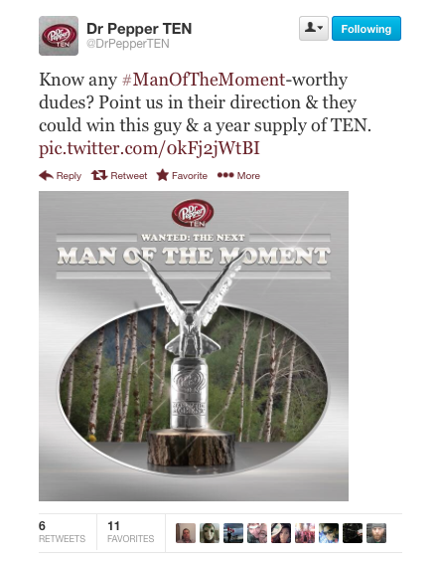

Every month Dr Pepper Ten does the “Man of the Moment” contest on Twitter where followers can nominate men using the hashtag #ManOfTheMoment. They can tell their manly moment for a chance to win the trophy shown in the photo and a year supply of Dr Pepper Ten. *Hosting contests on social media is an excellent incentive to get people interacting with the brand on their page. When someone tweets to Dr Pepper Ten with their entry, everyone they are following will see, thus bringing awareness to the brand. It also portrays a generous image for the brand by providing a year supply of the soda. By hosting the contest once a month, the brand continues to have people interacting with hope of winning the next month’s contest. The image is also eye-catching and goes along with their manly outdoor theme.*

Tweet #2:

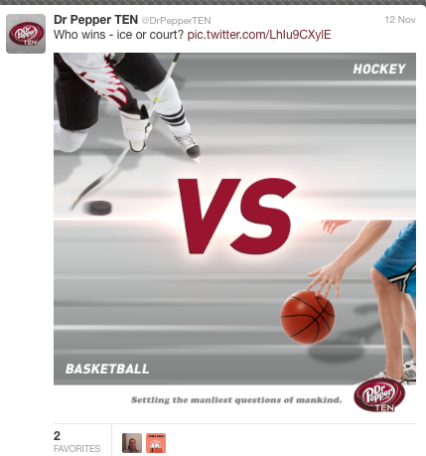

The next tweet asks, “Who wins – ice or court?” with eye-catching photo included. *Asking a question is always a good way to get followers interacting with a brand on social media. Even though the tweet doesn’t have anything to do with the soda, it is still masculine since it features sports that are dominated by men. Followers on Twitter do not want their feeds cluttered up with product placements being forced onto them, so it is nice that Dr Pepper Ten avoids talking about the actual soda in every tweet.* Dr Pepper continues to post these question images, which read at the bottom “Setting the manliest question of mankind”.

Tweet #3:

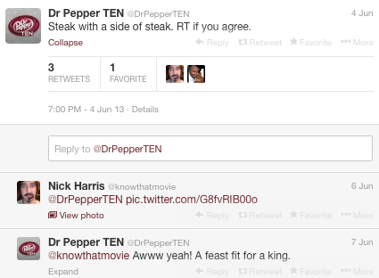

*The third tweet shown is a simple way to engage a brand’s followers. A simple statement like “steak with a side of steak” is short and relatable, and follows the stereotype of men liking meat. Short tweets are more likely to be read on a follower’s feed. They also added “RT if you agree” to their tweet. This reminds the viewers to retweet if the agree. This helps bring awareness to the brand since retweets send the tweet to everyone’s feed that is a follower.*

**Section 4: Integrated Marketing Communications**

Advertising, PR and Social Media all work together to create an effective brand experience. *For Dr Pepper’s Ten, the company stuck with the “It’s Not For Women” campaign. They continued to pursue the masculine theme through their advertisements, public relations, and social media. Their advertisements depict macho men doing outdoor action-pact adventures that still communicate the message that the low-calorie soda is still full of flavor. Their press coverage unveils the innovated technology behind creating the product, giving the brand an intelligent and unique reputation. Dr Pepper Ten carries its masculine theme to their social media sites like Twitter, where they host giveaways and spread the word with relatable humorous tweets. Their Facebook page is a virtual man cave that only men are able to access, where they can poke fun at women and embrace their masculinity. Some women were offended by the campaign calling it sexist and refusing to purchase Dr Pepper products, while other women had the attitude that they would prove men wrong and drink it anyways. Overall, the Dr Pepper Ten Integrated Marketing Communications is a unique and creative approach that syncs well together in order to maximize sales, and maintain brand equity.*

Works Cited

Dishman, Lydia. "Meet The Guy Who Whittled Dr Pepper Down To 10 Calories." Fast Company. N.p., 10 Dec. 2012. Web. 04 Dec. 2013. <http://www.fastcompany.com/3000981/meet-guy-who-whittled-dr-pepper-down-10- calories>.

Harrison, Nick. "Dr Pepper's Risky Strategy — Niche Marketing or Alienating?" *Craine's Chicago Business*. ChicagoBusiness.com, 31 Oct. 2011. Web. 04 Dec. 2013. <http://www.chicagobusiness.com/article/20111031/BLOGS06/111039993/nick- harrison-dr-peppers-risky-strategy-niche-marketing-or-alienating>.

Wells, Jane. "Dr Pepper Thinks 10 Is the Magic Number." CNBC. N.p., 30 Apr. 2013. Web. 03 Dec. 2013. <http://www.cnbc.com/id/100691083>.

"Dr Pepper TEN: Mountain Man Commercial." *YouTube*. N.p., 29 Mar. 2013. Web. 04 Dec. 2013. <http://www.youtube.com/watch?v=YDCY56azew8>.

"Dr. Pepper to Debut 5 New 10-calorie Sodas." Fox News. N.p., 19 Dec. 2012. Web. 04 Dec. 2013. <http://www.foxnews.com/health/2012/12/19/dr-pepper-to-debut-5-new-10- calorie-sodas/>.